Test Case: tc001_SPX_Dev5_Crear_Solicitud_Articulo_Almacen
Step 1 - Enter username and password and click to button Enter : Credentials Entered
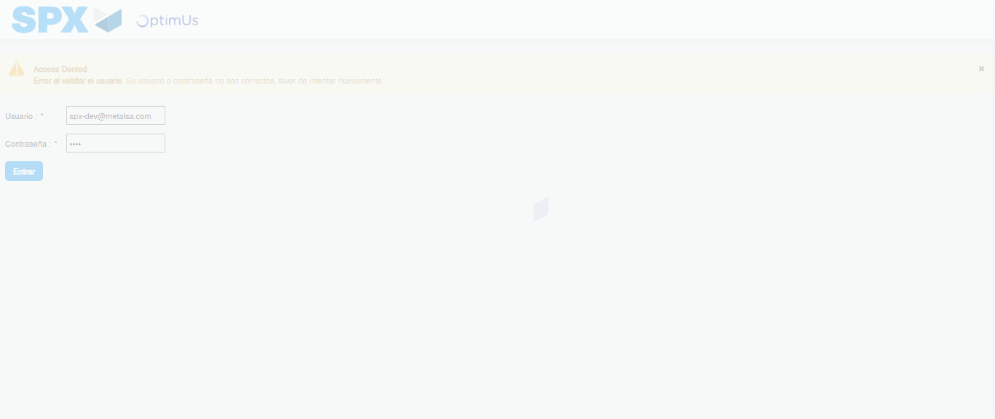Image file-name: QC_Testing-tc001_SPX_Dev5_Crear_Solicitud_Articulo_Almacen-1787871086632

Step 2 - Select to UEN and Access to Request for a New Inventory Item : UEN Correctly selected and Correct access
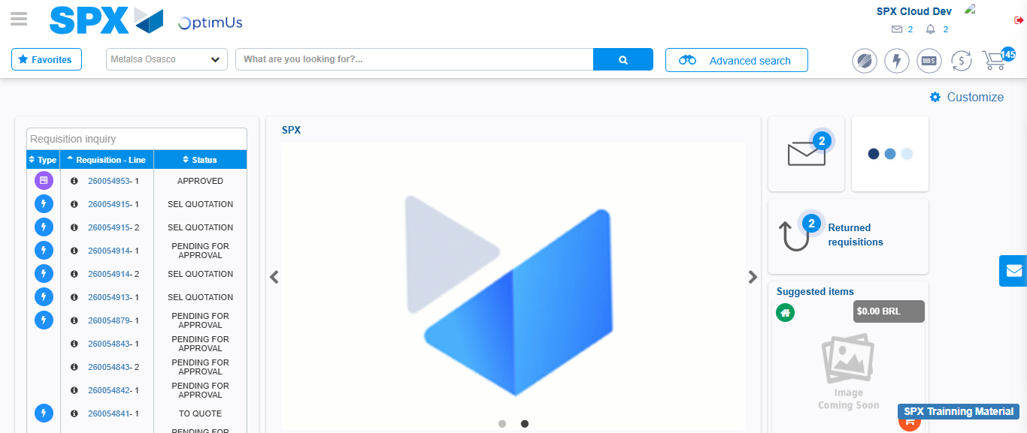Image file-name: QC_Testing-tc001_SPX_Dev5_Crear_Solicitud_Articulo_Almacen-1787871111850

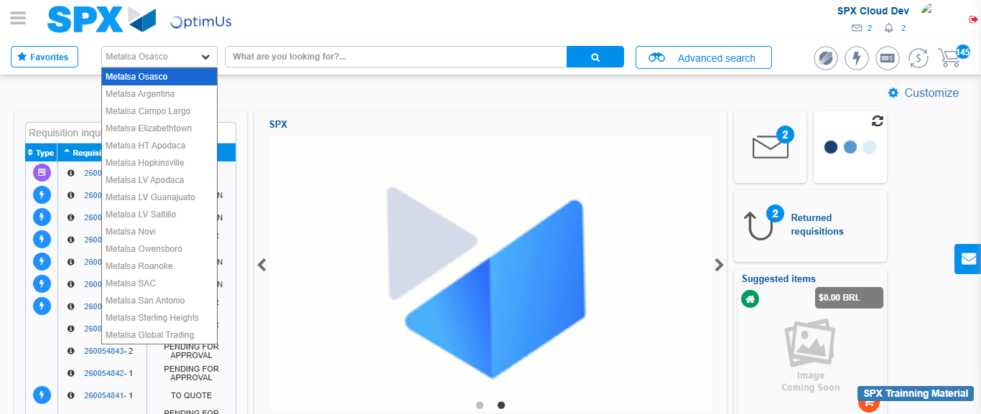Image file-name: QC_Testing-tc001_SPX_Dev5_Crear_Solicitud_Articulo_Almacen-1787871112376

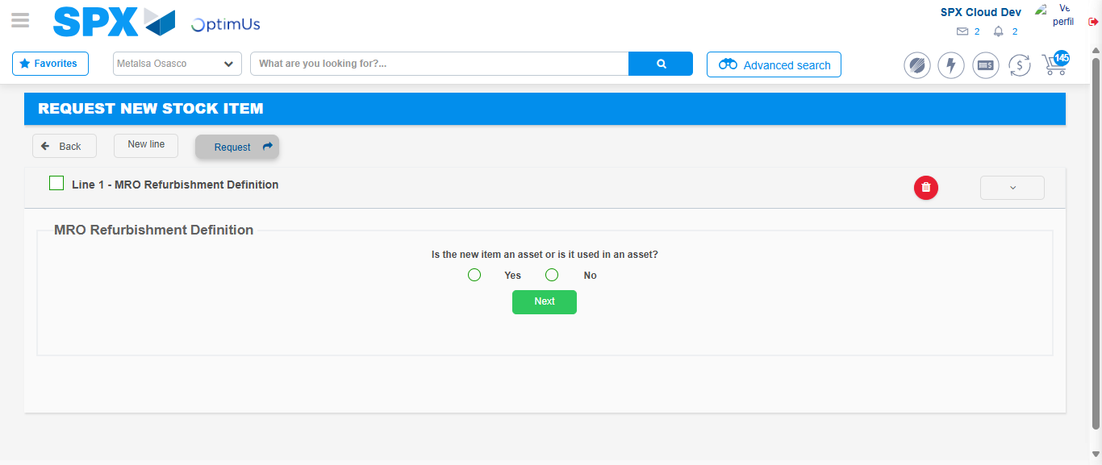Image file-name: QC_Testing-tc001_SPX_Dev5_Crear_Solicitud_Articulo_Almacen-1787871139604

Step 3 - Select options first section : Options seleted correctly
Image file-name: QC_Testing-tc001_SPX_Dev5_Crear_Solicitud_Articulo_Almacen-1787871139806

Image file-name: QC_Testing-tc001_SPX_Dev5_Crear_Solicitud_Articulo_Almacen-1787871139985

Step 4 - Select options at Screen: Options seleted correctly
Image file-name: QC_Testing-tc001_SPX_Dev5_Crear_Solicitud_Articulo_Almacen-1787871139806

Image file-name: QC_Testing-tc001_SPX_Dev5_Crear_Solicitud_Articulo_Almacen-1787871139985

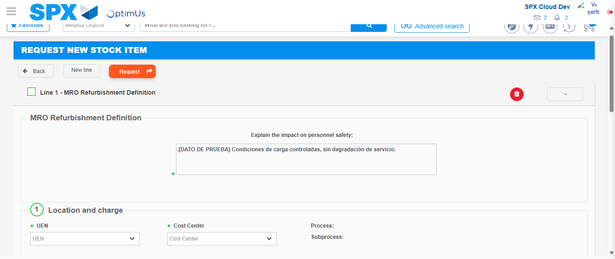Image file-name: QC_Testing-tc001_SPX_Dev5_Crear_Solicitud_Articulo_Almacen-1787871145903

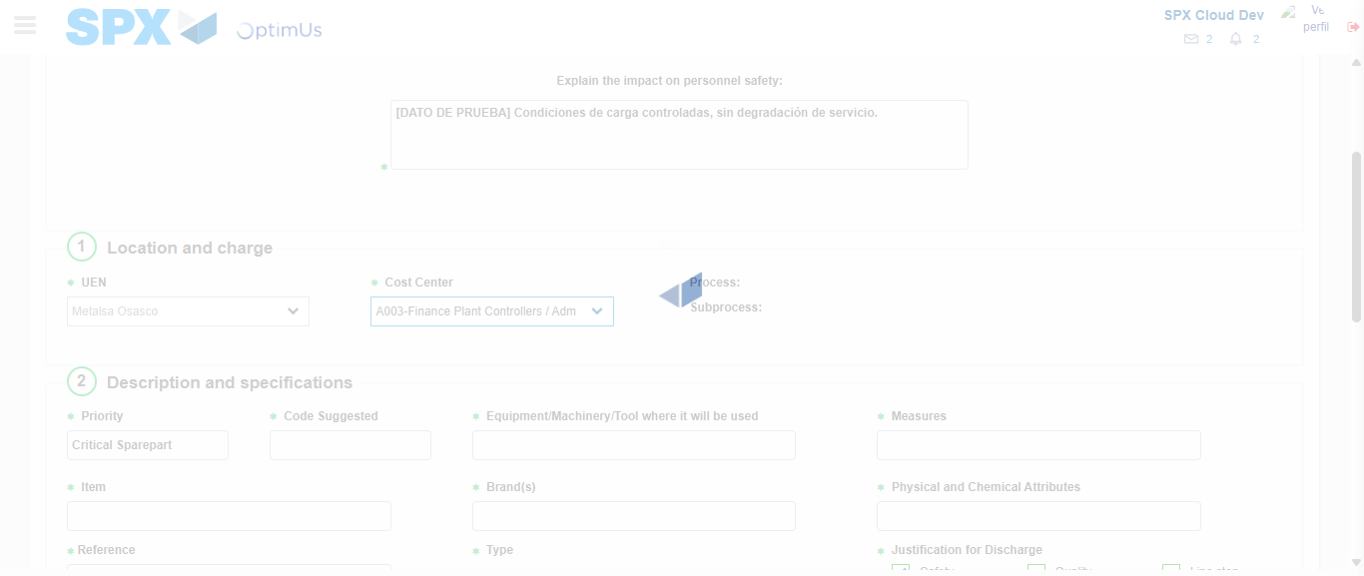Image file-name: QC_Testing-tc001_SPX_Dev5_Crear_Solicitud_Articulo_Almacen-1787871148290

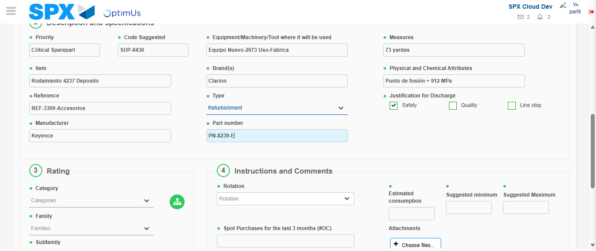Image file-name: QC_Testing-tc001_SPX_Dev5_Crear_Solicitud_Articulo_Almacen-1787871149573

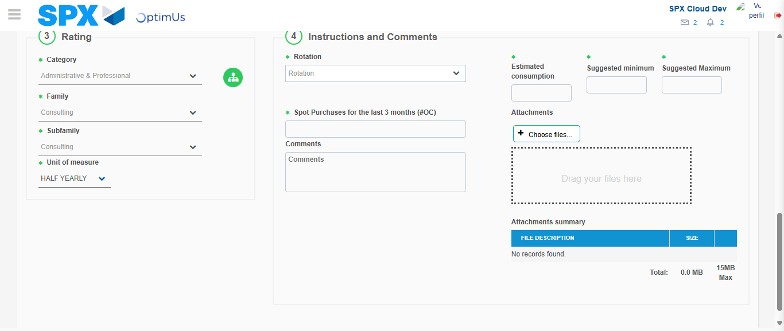Image file-name: QC_Testing-tc001_SPX_Dev5_Crear_Solicitud_Articulo_Almacen-1787871153098

Step 5 - Request New Item : Request Accepted
Image file-name: QC_Testing-tc001_SPX_Dev5_Crear_Solicitud_Articulo_Almacen-1787871111850

Image file-name: QC_Testing-tc001_SPX_Dev5_Crear_Solicitud_Articulo_Almacen-1787871112376

Image file-name: QC_Testing-tc001_SPX_Dev5_Crear_Solicitud_Articulo_Almacen-1787871139604

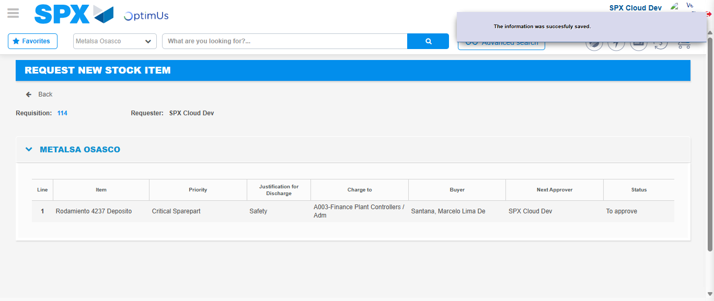Image file-name: QC_Testing-tc001_SPX_Dev5_Crear_Solicitud_Articulo_Almacen-1787871159633

Image file-name: QC_Testing-tc001_SPX_Dev5_Crear_Solicitud_Articulo_Almacen-1787871159788

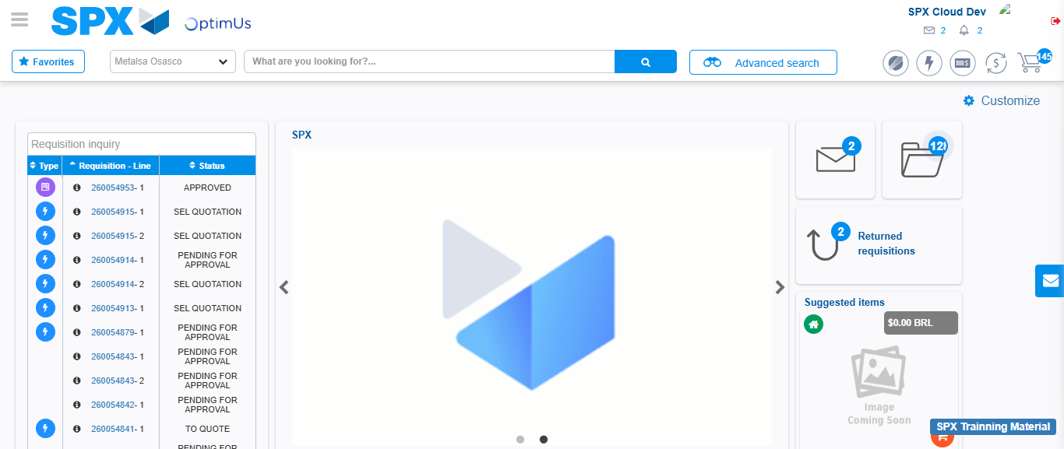Image file-name: QC_Testing-tc001_SPX_Dev5_Crear_Solicitud_Articulo_Almacen-1787871180834

Step 7 - Return to Main Page SPX : Return to Main Page SPX
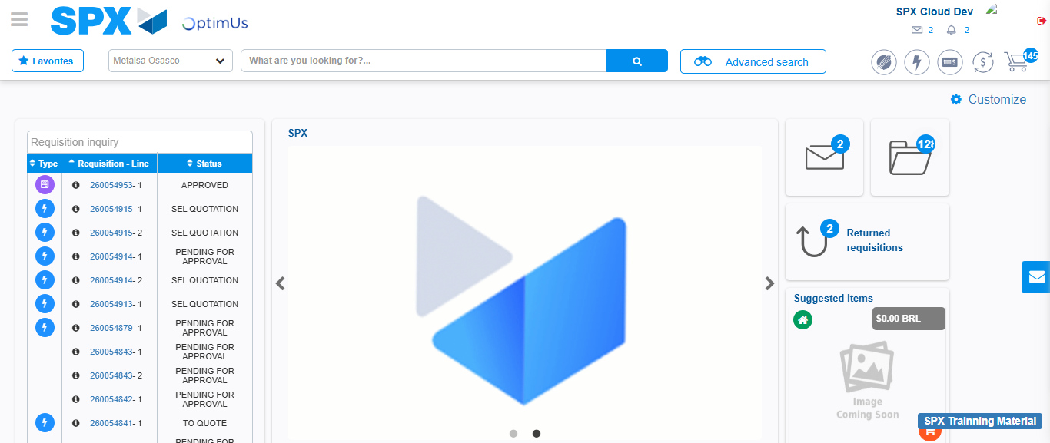Image file-name: QC_Testing-tc001_SPX_Dev5_Crear_Solicitud_Articulo_Almacen-1787871181094

